Practical : 12

## Aim: Develop a web page to implement the concept of state management using Session and Application.

First.aspx

<%@ Page Language="vb" AutoEventWireup="false" CodeBehind="First.aspx.vb" Inherits="Practical_12.First" %>

<!DOCTYPE html PUBLIC "-//W3C//DTD XHTML 1.0 Transitional//EN" "http://www.w3.org/TR/xhtml1/DTD/xhtml1-transitional.dtd">

<html xmlns="http://www.w3.org/1999/xhtml">

<head runat="server">

<title></title>

</head>

<body>

<form id="form1" runat="server">

<div>

<asp:TextBox ID="tb1" runat="server"></asp:TextBox>

<asp:Button ID="Button1" runat="server" Text="Login" />

</div>

</form>

</body>

</html>

First.aspx.vb

Public Class First

Inherits System.Web.UI.Page

Protected Sub Page_Load(ByVal sender As Object, ByVal e As System.EventArgs) Handles Me.Load

End Sub

Protected Sub Button1_Click(ByVal sender As Object, ByVal e As EventArgs) Handles Button1.Click

Session("username") = tb1.Text

Application("lastuser") = tb1.Text

Response.Redirect("Second.aspx")

End Sub

End Class

Second.aspx.vb

Public Class Second

Inherits System.Web.UI.Page

Protected Sub Page_Load(ByVal sender As Object, ByVal e As System.EventArgs) Handles Me.Load

Response.Write("Welcome : " & Session("username"))

Response.Write("<br />Last Logged User : " & Application("lastuser"))

End Sub

End Class

Output :



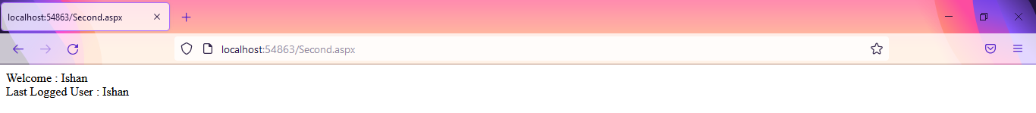

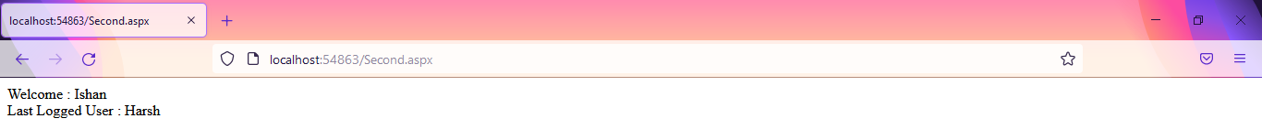

|  |  |  |  |
| --- | --- | --- | --- |
| Start Date | End/sign Date | Faculty Sign | Remarks/Grade |
|  |  |  |  |

Practical : 14

## Aim: Create a web application using **Global.asax** file which will count the number of visitors on web page.

Home.aspx

<%@ Page Language="vb" AutoEventWireup="false" CodeBehind="Home.aspx.vb" Inherits="Practical_14.Home" %>

<!DOCTYPE html PUBLIC "-//W3C//DTD XHTML 1.0 Transitional//EN" "http://www.w3.org/TR/xhtml1/DTD/xhtml1-transitional.dtd">

<html xmlns="http://www.w3.org/1999/xhtml">

<head runat="server">

<title></title>

</head>

<body>

<form id="form1" runat="server">

<div>

</div>

</form>

</body>

</html>

Home.aspx.vb

Public Class Home

Inherits System.Web.UI.Page

Protected Sub Page_Load(ByVal sender As Object, ByVal e As System.EventArgs) Handles Me.Load

Session.Timeout = 1

Response.Write("Total Visitors : " & Application("visitor"))

Response.Write("<br />Total Online : " & Application("online"))

End Sub

End Class

Global.asax.vb

Imports System.Web.SessionState

Public Class Global_asax

Inherits System.Web.HttpApplication

Sub Application_Start(ByVal sender As Object, ByVal e As EventArgs)

Application("visitor") = 0

Application("online") = 0

End Sub

Sub Session_Start(ByVal sender As Object, ByVal e As EventArgs)

Application("visitor") += 1

Application("online") += 1

End Sub

Sub Application_BeginRequest(ByVal sender As Object, ByVal e As EventArgs)

End Sub

Sub Application_AuthenticateRequest(ByVal sender As Object, ByVal e As EventArgs)

End Sub

Sub Application_Error(ByVal sender As Object, ByVal e As EventArgs)

End Sub

Sub Session_End(ByVal sender As Object, ByVal e As EventArgs)

Application("online") -= 1

End Sub

Sub Application_End(ByVal sender As Object, ByVal e As EventArgs)

End Sub

End Class

Output :

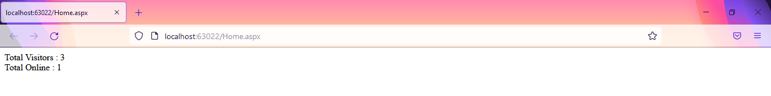

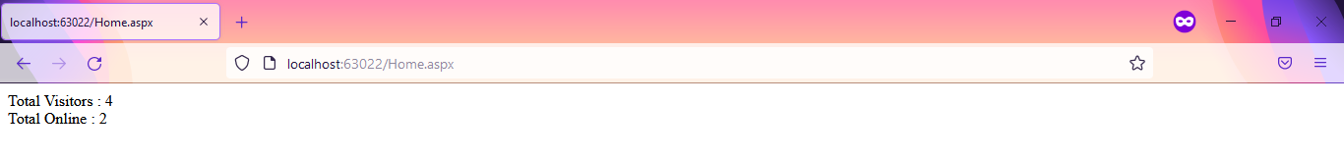

|  |  |  |  |
| --- | --- | --- | --- |
| Start Date | End/sign Date | Faculty Sign | Remarks/Grade |
|  |  |  |  |